Math Unit 2 Study Guide:
Ratios and Proportions

Standards Being Assessed:

6.RP.1
Understand the concept of a ratio and use ratio language to describe a ratio relationship between two quantities. For example, “The ratio of wings to beaks in the bird house at the zoo was 2:1, because for every 2 wings there was 1 beak.” “For every vote candidate A received, candidate C received nearly three votes.”

6.RP.2
Understand the concept of a unit rate a/b associated with a ratio a:b with b ≠ 0, and use rate language in the context of a ratio relationship. For example, “This recipe has a ratio of 3 cups of flour to 4 cups of sugar, so there is 3/4 cup of flour for each cup of sugar.” “We paid $75 for 15 hamburgers, which is a rate of $5 per hamburger.”

6.RP.3
Use ratio and rate reasoning to solve real-world and mathematical problems, e.g., by reasoning about tables of equivalent ratios, tape diagrams, double number line diagrams, or equations.
  - Make tables of equivalent ratios relating quantities with whole-number measurements, find missing values in the tables, and plot the pairs of values on the coordinate plane. Use tables to compare ratios.
  - Solve unit rate problems including those involving unit pricing and constant speed. For example, if it took 7 hours to mow 4 lawns, then at that rate, how many lawns could be mowed in 35 hours? At what rate were lawns being mowed?
  - Find a percent of a quantity as a rate per 100 (e.g., 30% of a quantity means 30/100 times the quantity); solve problems involving finding the whole, given a part and the percent.
  - Use ratio reasoning to convert measurement units; manipulate and transform units appropriately when multiplying or dividing quantities.

- Shakira is playing in a softball tournament for her city league. Looking at the calendar she sees her team has played 3 games and the season is 15% over. How many games will Shakira’s team play in the season? Use a table, diagram, or equation to justify your answer.

- As a doctor, Mr. Smith is paid $144,000 a year. He is required to pay 12% of his income to State and Federal taxes. How much does Mr. Smith make a month after taxes? Use a table, diagram, or equation to justify your answer.

- Jane is biking on a path between Surprise and Mesa. She has biked 30 of the 40 miles between the cities. What percent of the distance between Surprise and Mesa does Jane have left to ride? Use a table, diagram, or equation to justify your answer.

- Mountainside Fitness is considering adding an Olympic sized swimming pool to their gym facilities. An Olympic sized swimming pool is usually 50 meters in length, 25 meters in width and 2 meters deep. In order to maintain the pool, they need a pump that will be able to fill the pool automatically. Mountainside’s general manager, Jason, is comparing two pumps from local pool supply stores.

Pump A Pump B
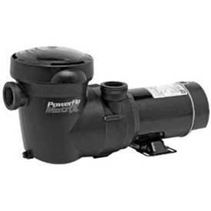
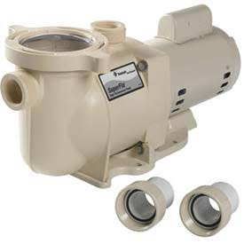

Can pump 1650Liters of water Can pump 2700 liters of water
in 3 minutes. in 5 minutes.

- What is the rate that Pump A can pump water into the pool? Give the rate and then specify the unit rate and rate unit.

- Which brand is the more efficient for pumping water into the pool?

- Jason searches online for how much water is needed to fill one cubic meter and finds the answer to be 1,000 Liters. Choose one of the pumps and calculate how long it will take the pump to fill the pool. Be sure to specify which brand you chose.

- Three friends, Jessica, James, and Rico decided to drive from Albuquerque to Anaheim to go to Disneyland for a vacation . Each driver set the cruise control during their leg of the trip, enabling them to travel at a constant speed. The friends changed drivers each time they stopped for gas. Jessica drove for 3 hours at a constant speed of 75 miles per hour. James drove at a speed of 68 miles per hour for 4 ½ hours, and then Rico drove for 3.75 hours, going 65 miles per hour.

- How far is Disneyland from Albuquerque?

- How long did the trip take?

- Which driver would have gotten them to Disneyland the fastest? Approximately how long would the trip had taken if this friend drove the whole way?

- A fourth friend, Rachel, left Phoenix at the same times as the others in a different car. If she travels at a constant speed of 70 miles per hour. Will Rachel reach Disneyland before or after her friends? How do you know? Use words, diagrams, or numbers to explain your reasoning.

