Blooms

Taxonomy

Remember:

**Recalling information from long-term memory**

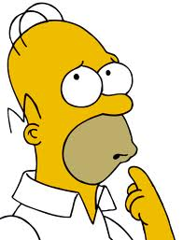

**QUESTIONS:**

* What happened after…?
* How many…?
* What is…?
* Who was it that…?
* Describe what happened after…
* Which is true or false…?
* Who spoke to…?
* Can you name…?
* Name each of the…
* Find the meaning of…

**VERBS:**

*Recognize List*

*Describe Name*

*Retrieve Find*

*Identify Recall*

**Activities & Products:**

1.Make a list of the main events/

points of the text

2. Make a time line of events

3. Make a facts chart

4. Write a list of any pieces of

information you can remember

5. Make a chart showing

6. Make an acrostic

7. Recite a poem

Understand:

**Explaining ideas or concepts**

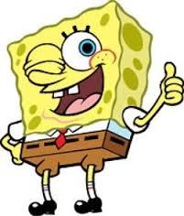

**QUESTIONS:**

* State in your own words
* Which are facts?
* Give an example
* Condense this paragraph
* Explain what happened
* What part doesn’t fit?
* Show in a graph/chart
* Which statement supports…?
* State in one word…
* What was the main idea?
* Draw a story map
* Clarify why….?

**VERBS:**

*Interpret Summarize*

*Classify Infer*

*Compare Explain*

*Paraphrase Exemplify*

**Activities & Products:**

* **Cut out/draw pictures to show an event**
* **Illustrate the main idea**
* **Make a cartoon strip showing the sequence of events**
* **Write and perform a play based on the text**
* **Retell the text in your own words**
* **Write a summary of the text**
* **Prepare a flow chart to illustrate the sequence of events**

Apply:

**Using information for another familiar situation or task**

**QUESTIONS:**

* What would happen if…?
* Tell how, when, where why?
* Tell how much change there would be…
* How would you use…?
* What is the principle (rule, concept, idea) behind…?
* Do you know of another instance where…?
* Can you group by characteristics such as…?
* Which factors would you change if…?
* What questions would you ask of…?
* From the information given, can you develop a set of instructions about…?

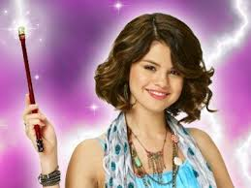

**VERBS:**

*Implement Use*

*Carry out Execute*

**Activities & Products:**

* **Construct a model to demonstrate how it works**
* **Make a diorama to illustrate an event**
* **Make a scrapbook about the area of study**
* **Make up a puzzle or game about the topic**
* **Write a brochure for others about this topic**
* **Paint a mural using the same materials**
* **Design a marketing strategy for your product using a known strategy as a model**
* **Take a collection of photographs to demonstrate a particular point**

Analyze:

**Breaking information into parts to explore how those parts relate to one another and to an overall structure or purpose**

**QUESTIONS:**

* What is the function of…?
* What does the author/character believe?
* Make a distinction between…
* What is the relationship between…
* What evidence do you find?
* How would you diagram the sequence structure of…?
* If…happened, what might the ending have been?
* How is…similar to…?
* Explain what must have happened when…?
* What are some of the motives behind…?
* What was the turning point?

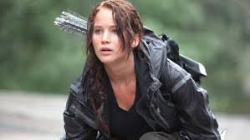

**VERBS:**

*Differentiate Organize*

*Attribute Comparing*

*Deconstruct Interrogate*

**Activities & Products:**

* **Design a questionnaire to gather information**
* **Write a commercial to sell a new product**
* **Make a flow chart to show critical stages**
* **Construct a graph to illustrate selected information**
* **Make a family tree showing relationships**
* **Devise a play about the study area**
* **Write a biography of a person studied**
* **Prepare a report about the area of study**
* **Conduct an investigation to produce information to support a view**
* **Review a work of art in terms of form, color and texture.**

Evaluate:

**Justifying a decision or course of action based on criteria and standards**

**QUESTIONS:**

* What fallacies/consistencies/ inconsistencies appear?
* Which is more important/logical/ appropriate?
* Find the errors in…
* What might have been a better solution?
* How would you justify…?
* Judge the value of…What do you think about…?
* Defend your position on…
* What changes to … would you recommend?
* How effective are…?
* What are the pros and cons of…?
* What influence will … have on …?
* Why is … of value?

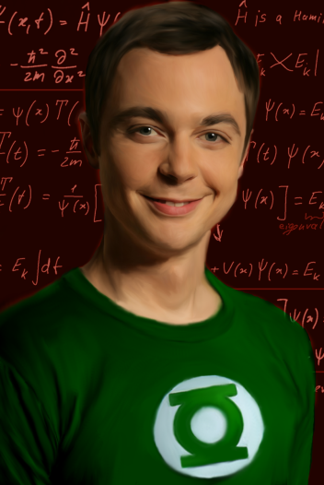

**VERBS:**

*Check Determine*

*Critique Hypothesize*

*Experiment Judge*

**Activities & Products:**

* **Prepare a list of criteria to judge…**
* **Conduct a debate about an issue of special interest**
* **Make a booklet about five rules you see as important. Convince others.**
* **Form a panel to discuss views**
* **Write a letter to ... advising on changes needed**
* **Write a half-yearly report**
* **Prepare a case to present your view about…**

Create:

**Generating new ideas, products, or ways of viewing things**

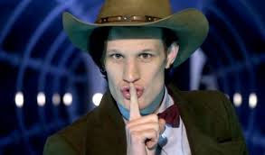

**QUESTIONS:**

* How would you test…?
* Propose an alternative
* Find the errors in…
* What could you improve/change/ modify/maximize/fix?
* How could you use…to solve/prove…?
* Design a … to….
* If you had access to all resources, how would you deal with …?
* How many ways can you….?
* Create a new and unusual use for…
* Develop a proposal which would…
* Find a possible solution to…

**VERBS:**

*Generate Plan*

*Produce Design*

*Construct Invent*

**Activities & Products:**

* **Invent a machine to do a specific task**
* **Design a building to house your study**
* **Create a new product. Give it a name and plan a marketing campaign**
* **Write about your feelings in relation to…**
* **Write a TV show, play, puppet show, role play, song or pantomime about…**
* **Design a record, book or magazine cover for…**
* **Devise a way to…**
* **Make up a new language and use it in an example**